// classes example
#include <iostream.h>

class CRectangle {
int width, height;
public:
CRectangle (int,int);
int area (void) {return (width*height);}
};

CRectangle::CRectangle (int a, int b) {
width = a;
height = b;
}

int main () {
CRectangle rect (3,4);
CRectangle rectb (5,6);
cout << "rect area: " << rect.area() << endl;
cout << "rectb area: " << rectb.area() << endl;
return 0;
}

// example on constructors and destructors

#include <iostream.h>

class CRectangle {
int *width, *height;
public:
CRectangle (int,int);
~CRectangle ();
int area (void) {return (*width * *height);}
};

CRectangle::CRectangle (int a, int b) {
width = new int;
height = new int;
*width = a;
*height = b;
}

CRectangle::~CRectangle () {
delete width;
delete height;
}

int main () {
CRectangle rect (3,4), rectb (5,6);
cout << "rect area: " << rect.area() << endl;
cout << "rectb area: " << rectb.area() << endl;
return 0;
}

// overloading class constructors
#include <iostream.h>

class CRectangle {
int width, height;

public:
CRectangle ();
CRectangle (int,int);
int area (void) {return (width*height);}
};

CRectangle::CRectangle () {
width = 5;
height = 5;
}

CRectangle::CRectangle (int a, int b) {
width = a;
height = b;
}

int main () {
CRectangle rect (3,4);
CRectangle rectb;
cout << "rect area: " << rect.area() << endl;
cout << "rectb area: " << rectb.area() << endl;
}

// friend functions
#include <iostream.h>

class CRectangle {
int width, height;
public:
void set_values (int, int);
int area (void) {return (width * height);}
friend CRectangle duplicate (CRectangle);
};

void CRectangle::set_values (int a, int b) {
width = a;
height = b;
}

CRectangle duplicate (CRectangle rectparam)
{
CRectangle rectres;
rectres.width = rectparam.width*2;
rectres.height = rectparam.height*2;
return (rectres);
}

int main () {
CRectangle rect, rectb;
rect.set_values (2,3);
rectb = duplicate (rect);
cout << rectb.area();
}

Output: 24

// friend class
#include <iostream.h>
class CSquare;

class CRectangle {
int width, height;
public:
int area (void)
{return (width * height);}
void convert (CSquare a);
};

class CSquare {
private:
int side;
public:
void set_side (int a)
{side=a;}
friend class CRectangle;
};

void CRectangle::convert (CSquare a) {
width = a.side;
height = a.side;
}

int main () {
CSquare sqr;
CRectangle rect;
sqr.set_side(4);
rect.convert(sqr);
cout << rect.area();
return 0;
}

Output: 16

Inheritance between classes

class derived_class_name: public base_class_name;

// base class

#include <iostream.h>
class CPolygon {
protected:
int width, height;
public:
void set_values (int a, int b)
{ width=a; height=b;}
};

// derived classes

class CRectangle: public CPolygon {
public:
int area (void)
{ return (width * height); }
};

class CTriangle: public CPolygon {
public:
int area (void)
{ return (width * height / 2); }
};

int main () {
CRectangle rect;
CTriangle trgl;
rect.set_values (4,5);
trgl.set_values (4,5);
cout << rect.area() << endl;
cout << trgl.area() << endl;
return 0;
}

Output: 20 10

What is not inherited from the base class?

l Constructor and destructor
l operator=() member
l friends

derived_class_name (parameters) : base_class_name
(parameters) {}

// constructors and derivated classes
#include <iostream.h>
class mother {
public:

mother ()
{ cout << "mother: no parameters\n"; }

mother (int a)
{ cout << "mother: int parameter\n"; }
};

class daughter : public mother {
public:
daughter (int a)
{ cout << "daughter: int parameter\n\n"; }
};

class son : public mother {
public:
son (int a) : mother (a)
{ cout << "son: int parameter\n\n"; }
};

int main () {
daughter cynthia (1);
son daniel(1);
return 0;
}

Output:
mother:no parameters
daughter:int parameter
mother:int parameter
son: int parameter

Multiple inheritance

// multiple inheritance
#include <iostream.h>
class CPolygon {
protected:
int width, height;
public:
void set_values (int a, int b)
{ width=a; height=b;}
};

class COutput {
public:
void output (int i);
};

void COutput::output (int i) {
cout << i << endl;
}

class CRectangle: public CPolygon, public COutput {
public:
int area (void)
{ return (width * height); }
};

class CTriangle: public CPolygon, public COutput {
public:
int area (void)
{ return (width * height / 2); }
};

int main () {
CRectangle rect;
CTriangle trgl;
rect.set_values (4,5);
trgl.set_values (4,5);
rect.output (rect.area());
trgl.output (trgl.area());
return 0;
}

Output: 20
10

Copy Constructor

When one object explicitly initializes another, such as in a declaration
MyClass x = y; // y explicitly initializing x

When a copy of an object is made to be passed to a function
func1(y); // y passed as a parameter

When a temporary object is generated (most commonly, as a return value)
y = func2(); // y receiving a returned object

The copy constructor applies only to initializations. The copy constructor does not apply to assignments.
The most common form of copy constructor is shown here:

classname (const classname &obj) {

// body of constructor }
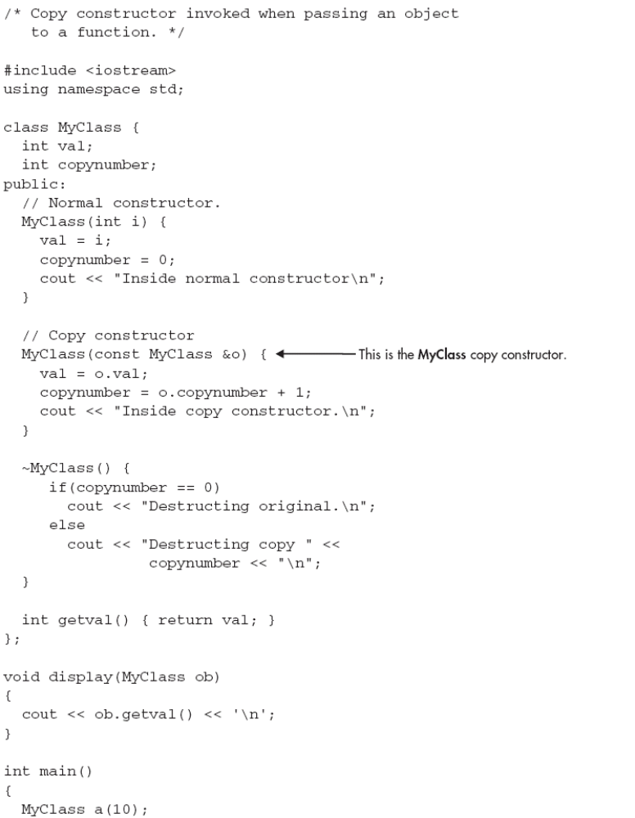
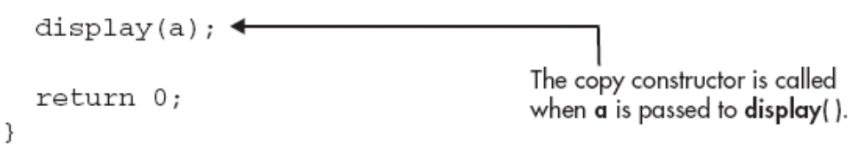

This program displays the following output:
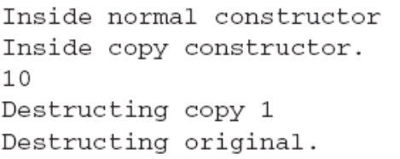

Pointers to base class

// pointers to base class
#include <iostream.h>
class CPolygon {
protected:
int width, height;
public:
void set_values (int a, int b)
{ width=a; height=b; }
};
class CRectangle: public CPolygon {
public:
int area (void)
{ return (width * height); }
};
class CTriangle: public CPolygon {
public:
int area (void)
{ return (width * height / 2); }
};
int main () {
CRectangle rect;
CTriangle trgl;
CPolygon * ppoly1 = &rect;
CPolygon * ppoly2 = &trgl;
ppoly1->set_values (4,5);
ppoly2->set_values (4,5);
cout << rect.area() << endl;
cout << trgl.area() << endl;
return 0;
}

Virtual members

// virtual members
#include <iostream.h>

class CPolygon {
protected:
int width, height;
public:

void set_values (int a, int b)
{ width=a; height=b; }

virtual int area (void)
{ return (0); }

};

class CRectangle: public CPolygon {
public:
int area (void)
{ return (width * height); }
};
class CTriangle: public CPolygon {
public:
int area (void)
{ return (width * height / 2); }
};
int main () {
CRectangle rect;
CTriangle trgl;
CPolygon poly;
CPolygon * ppoly1 = &rect;
CPolygon * ppoly2 = &trgl;
CPolygon * ppoly3 = &poly;
ppoly1->set_values (4,5);
ppoly2->set_values (4,5);
ppoly3->set_values (4,5);
cout << ppoly1->area() << endl;
cout << ppoly2->area() << endl;
cout << ppoly3->area() << endl;
return 0;
}

Output:
20
10
0

Abstract base classes

// abstract class CPolygon
class CPolygon {
protected:
int width, height;
public:
void set_values (int a, int b)
{ width=a; height=b; }
virtual int area (void) =0;
};

Templates
Function templates

template <class identifier> function_declaration;
template <typename identifier> function_declaration;

template <class GenericType>
GenericType GetMax (GenericType a, GenericType b) {
return (a>b?a:b);
}

function <pattern> (parameters);

int x,y;
GetMax <int> (x,y);

// function template
#include <iostream.h>
template <class T>
T GetMax (T a, T b) {
T result;
result = (a>b)? a : b;
return (result);
}
int main () {
int i=5, j=6, k;
long l=10, m=5, n;
k=GetMax<int>(i,j);
n=GetMax<long>(l,m);
cout << k << endl;
cout << n << endl;
return 0;
}

6
10

// function template II
#include <iostream.h>
template <class T>
T GetMax (T a, T b) {
return (a>b?a:b);
}
int main () {
int i=5, j=6, k;
long l=10, m=5, n;
k=GetMax(i,j);
n=GetMax(l,m);
cout << k << endl;
cout << n << endl;
return 0;
}

Class templates

template <class T>
class pair {
T values [2];
public:
pair (T first, T second)
{
values[0]=first; values[1]=second;
}
};

pair<int> myobject (115, 36);

pair<float> myfloats (3.0, 2.18);

// class templates
#include <iostream.h>
template <class T>
class pair {
T value1, value2;
public:
pair (T first, T second)
{value1=first; value2=second;}
T getmax ();
};
template <class T>
T pair<T>::getmax ()
{
T retval;
retval = value1>value2? value1 : value2;
return retval;
}
int main () {
pair <int> myobject (100, 75);
cout << myobject.getmax();
return 0;
}

100

